90

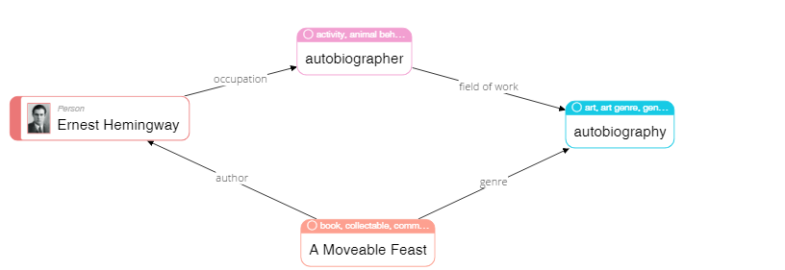

|  |
| --- |
| **Please describe shortly what you see on this diagram? Pay attention only to that information that is understandable or has sense for you.** |
| A Moveable Feast is a book written by Ernest Hemingway (his autobiography). |

68

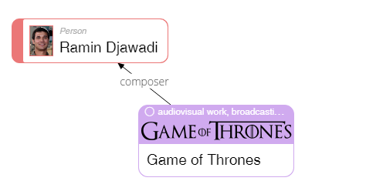

|  |
| --- |
| **Please describe shortly what you see on this diagram? Pay attention only to that information that is understandable or has sense for you.** |
| Audiovisual work "Game of Thrones" made Ramin Djawadi known as a composer. |

23

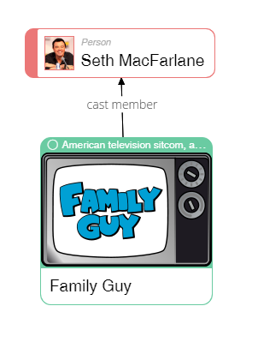

|  |
| --- |
| **Please describe shortly what you see on this diagram? Pay attention only to that information that is understandable or has sense for you.** |
| Seth MacFarlane is known as a cast member of American television sitcom. |

50

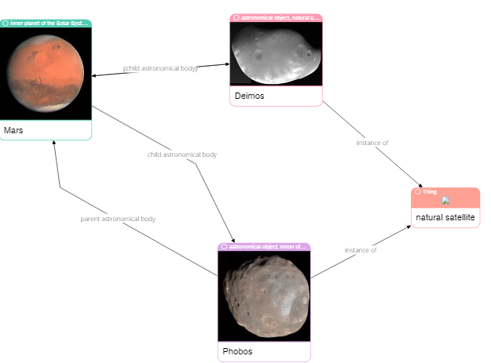

|  |
| --- |
| **Please describe shortly what you see on this diagram? Pay attention only to that information that is understandable or has sense for you.** |
| Both Phobos and Deimos are natural satellites of Mars, Deimos is being considered as a part of Mars before it became it's satellite. |

62

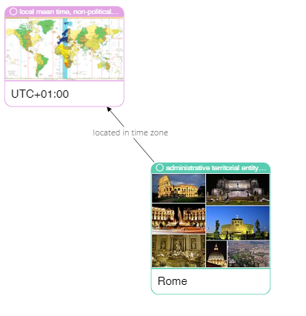

|  |
| --- |
| **Please describe shortly what you see on this diagram? Pay attention only to that information that is understandable or has sense for you.** |
| Rome is located in UTC +1 time zone. |

75

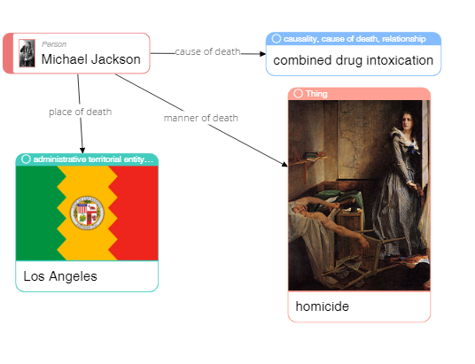

|  |
| --- |
| **Please describe shortly what you see on this diagram? Pay attention only to that information that is understandable or has sense for you.** |
| Michael Jackson died in LA after he had deliberately taken overdose of different drugs. |

79

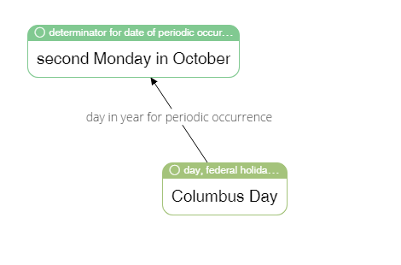

|  |
| --- |
| **Please describe shortly what you see on this diagram? Pay attention only to that information that is understandable or has sense for you.** |
| Columbus Day is celebrated on second Monday in October. |

65



|  |
| --- |
| **Please describe shortly what you see on this diagram? Pay attention only to that information that is understandable or has sense for you.** |
| An entrepreneur and inventor of LEGO Ole Kirk Cristiansen implicitely (through the game invented)  fosters  acquiring  different skills (carpenter, joiner, etc.) |

4

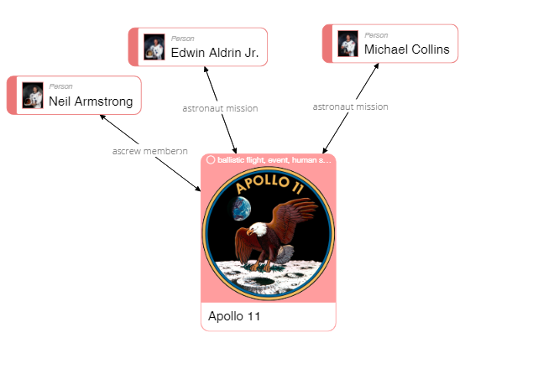

|  |
| --- |
| **Please describe shortly what you see on this diagram? Pay attention only to that information that is understandable or has sense for you.** |
| APPOLLO 11 spacecraft team included three members with Edwin Aldrin Jr., Michael Colins being astronauts and Neil Armstrong being a crew member. |

40

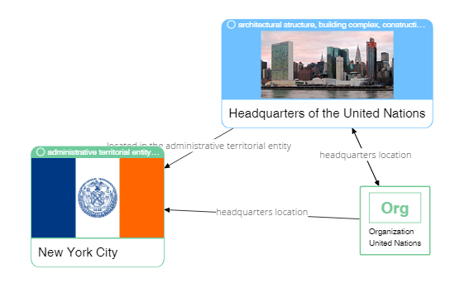

|  |
| --- |
| **Please describe shortly what you see on this diagram? Pay attention only to that information that is understandable or has sense for you.** |
| Headquarters of the UN is located in NYC |

37



|  |
| --- |
| **Please describe shortly what you see on this diagram? Pay attention only to that information that is understandable or has sense for you.** |
| Football club Porto is based in Porto city with home stadium being Estadio do Dragao. |